**Swinburne University of Technology**

School of Science, Computing and Engineering Technologies

**FINAL EXAM COVER SHEET**

**Subject Code:** COS30008

**Subject Title:** Data Structures & Patterns

## Due date: Lecturer:

April 9, 2025, 16:00

Dr. James Jackson

## Your name: Nguyen Gia Binh Your student id: 104219428

|  |  |  |  |  |  |  |  |  |  |  |  |
| --- | --- | --- | --- | --- | --- | --- | --- | --- | --- | --- | --- |
| Check Tutorial | Mon 10:30 | Mon 14:30 | Tues 08:30 | Tues 10:30 | Tues 12:30 | Tues 14:30 | Tues 16:30 | Wed 08:30 | Wed 10:30 | Wed 12:30 | Sat 10:00 |
|  |  |  |  |  |  |  |  |  |  | X |

Marker's comments:

|  |  |  |  |
| --- | --- | --- | --- |
| Problem | Marks | Time Estimate in minutes | Obtained |
| 1 | 132 | 30 |  |
| 2 | 56 | 10 |  |
| 3 | 60 | 15 |  |
| 4 | 10+88=98 | 45 |  |
| 5 | 50 | 20 |  |
| Total | 396 | 120 |  |

This test requires approx. 2 hours and accounts for 50% of your overall mark.

# 3-ary Trees and Prefix Traversal

We wish to define a generic 3-ary tree in C++. We shall call this data type TernaryTree. Our 3-ary tree has a payload key fKey and an array fSubTrees to store 3-ary subtrees. Following the principles underlying the definition of general trees, a 3-ary tree is a finite set of nodes and it is either

* an empty set, or
* a set that consists of a root and exactly 3 distinct 3-ary subtrees.

Somebody has already started with the implementation and created the header file

TernaryTree.h, but left the project unfinished (see Canvas).

**#pragma once**

**#include** <stdexcept>

**#include** <algorithm>

**template**<**typename** T>

**class** TernaryTreePrefixIterator;

**template**<**typename** T>

**class** TernaryTree

{

**public**:

**using** TTree = TernaryTree<T>;

**using** TSubTree = TTree**\***;

**private**: T fKey;

TSubTree fSubTrees[3];

// private default constructor used for declaration of NIL TernaryTree() :

fKey(T())

{

**for** ( size_t i = 0; i < 3; i++ )

{

fSubTrees[i] = **&**NIL;

}

}

**public**:

**using** Iterator = TernaryTreePrefixIterator<T>;

**static** TTree NIL; // sentinel

// getters for subtrees

**const** TTree**&** getLeft() **const** { **return \***fSubTrees[0]; } **const** TTree**&** getMiddle() **const** { **return \***fSubTrees[1]; } **const** TTree**&** getRight() **const** { **return \***fSubTrees[2]; }

// add a subtree

**void** addLeft( **const** TTree**&** aTTree ) { addSubTree( 0, aTTree ); } **void** addMiddle( **const** TTree**&** aTTree ) { addSubTree( 1, aTTree ); } **void** addRight( **const** TTree**&** aTTree ) { addSubTree( 2, aTTree ); }

// remove a subtree, may through a domain error

**const** TTree**&** removeLeft() { **return** removeSubTree( 0 ); } **const** TTree**&** removeMiddle() { **return** removeSubTree( 1 ); } **const** TTree**&** removeRight() { **return** removeSubTree( 2 ); }

/////////////////////////////////////////////////////////////////////////

// Problem 1: TernaryTree Basic Infrastructure

**private**:

// remove a subtree, may throw a domain error [22]

**const** TTree& removeSubTree( size_t aSubtreeIndex );

// add a subtree; must avoid memory leaks; may throw domain error [18]

**void** addSubTree( size_t aSubtreeIndex, **const** TTree**&** aTTree );

**public**:

// TernaryTree l-value constructor [10] TernaryTree( **const** T**&** aKey );

// destructor (free sub-trees, must not free empty trees) [14]

~TernaryTree();

// return key value, may throw domain_error if empty [6]

**const** T**& operator\***() **const**;

// returns true if this ternary tree is empty [4]

**bool** empty() **const**;

// returns true if this ternary tree is a leaf [10]

**bool** leaf() **const**;

// return height of ternary tree, may throw domain_error if empty [48] size_t height() **const**;

/////////////////////////////////////////////////////////////////////////

// Problem 2: TernaryTree Copy Semantics

// copy constructor, must not copy empty ternary tree [10] TernaryTree( **const** TTree**&** aOtherTTree );

// copy assignment operator, must not copy empty ternary tree

// may throw a domain error on attempts to copy NIL [36] TTree**& operator=**( **const** TTree**&** aOtherTTree );

// clone ternary tree, must not copy empty trees [10] TSubTree clone() **const**;

/////////////////////////////////////////////////////////////////////////

// Problem 3: TernaryTree Move Semantics

// TTree r-value constructor [12] TernaryTree( T**&&** aKey );

// move constructor, must not copy empty ternary tree [12] TernaryTree( TTree**&&** aOtherTTree );

// move assignment operator, must not copy empty ternary tree [36] TTree**& operator=**( TTree**&&** aOtherTTree );

/////////////////////////////////////////////////////////////////////////

// Problem 4: TernaryTree Prefix Iterator

// return ternary tree prefix iterator positioned at start [4] Iterator begin() **const**;

// return ternary prefix iterator positioned at end [6] Iterator end() **const**;

};

template<typename T>

TernaryTree<T> TernaryTree<T>::NIL;

There are actual two template classes here: TernaryTree<T> and TernaryTreePrefixIterator<T>. The two template classes occur mutually dependent. However, as long as we do not use the iterator elements template class TernaryTree<T> can be safely implemented. The C++ compiler ignores unimplemented features that are not used.

The implementation of TernaryTree<T> is defined in three stages: basic infrastructure, copy control and, move semantics.

Once these stages are completed, we can focus our attention on the prefix iterator part.

You may always assume that previous steps produced a correct implementation. However, it does not guarantee that you can thoroughly test all steps.

# Problem 1 (132 marks)

Implement the basic TernaryTree<T> infrastructure:

* **const** TTree<T>**&** removeSubTree( size_t aSubtreeIndex );
* **void** addSubTree( size_t aSubtreeIndex, **const** TTree**&** aTTree );
* TernaryTree( **const** T**&** aKey );
* ~TernaryTree();
* **const** T**& operator\***() **const**;
* **bool** empty() **const**;
* **bool** leaf() **const**;
* size_t height() **const**;

Use the available information to implement these features. The method removeSubTree() has to guarantee that empty trees are not removed. In this case, removeSubTree() has to throw a domain error. If the subtree can be removed, then a constant reference to it must be returned. In addition, the pointer of the subtree being removed must be set the address of NIL to indicate that this branch is now empty.

The method addSubTree() adds a new 3-ary subtree at index aSubtreeIndex. The index must be valid and the slot in the array fSubTrees must be available (i.e., set to the address of NIL). If any error occurs, the method addSubTree() must throw a corresponding exception.

To create TernaryTree<T> objects, we need to define its constructor, and the destructor releases the memory associated with TernaryTree<T> objects. The empty tree must not be deleted. It is unique and system-created.

In addition, there are four service functions: **operator\***(), empty(), leaf(), and height() that return the payload of a TernaryTree<T> object, test whether the current TernaryTree<T> object is the empty tree, check whether the current TernaryTree<T> object is a leaf node, and return the height of the current TernaryTree<T> object, respectively. Please note that the height of an empty tree is undefined.

You can use #define P1 in Main.cpp to enable the corresponding test driver, if you wish to compile and test your solution. The test driver should produce the following output:

Test Problem 1:

Setting up ternary tree...

Successfully caught: Subtree is not NIL Testing basic ternary tree logic ...

Is NIL empty? Yes Is root empty? No Height of root is: 3

Successfully caught: Operation not supported Tearing down ternary tree...

Successfully caught: Subtree is NIL

Nodes nA, nB, nC get destroyed by destructor. Test Problem 1 complete.

No other outputs or errors should occur.

# Problem 2 (56 marks)

Implement copy control for TernaryTree<T>:

* TernaryTree( **const** TTree**&** aOtherTTree );
* TTree**& operator=**( **const** TTree**&** aOtherTTree );
* TSubTree clone() **const**;

Use the available information to implement these features.

The copy control must not create copies of empty trees. If an empty tree is encountered in the copy constructor or assignment operator, then a domain error must be thrown. The method clone() can easily prevent copies of empty trees by returning the this object. You may need to apply suitable casts where necessary to make the implementation sound.

You can use #define P2 in Main.cpp to enable the corresponding test driver, if you wish to compile and test your solution. The test driver should produce the following output:

Test Problem 2:

Copy constructor appears to work properly. Copy constructor preserves tree structure. Assignment appears to work properly.

Assignment preserves tree structure.

Successfully caught: NIL as source not permitted. Clone appears to work properly.

Trees root and copy get deleted next. Test Problem 2 complete.

No other outputs or errors should occur. If the destructor and the elements of copy control work, then, at the end, when objects root and copy go out of scope, they are properly destroyed. No memory errors should occur.

# Problem 3 (60 marks)

Implement move semantics for TTree<T>:

* TernaryTree( T**&&** aKey );
* TernaryTree( TTree&**&** aOtherTTree );
* TTree**& operator=**( TTree**&&** aOtherTTree );

Use the available information to implement these features.

Move semantics avoids copying data when possible. We achieve move semantics by “stealing” the memory associated with the objects being moved. Move semantics uses r-value references. If you use an l-value as an argument to a move operation, then we should find that l-value empty after the move operation. We can use this feature to test out implementation.

You can use #define P3 in Main.cpp to enable the corresponding test driver, if you wish to compile and test your solution. The test driver should produce the following output:

Test Problem 3:

std::move makes root a leaf node. The payload of tree: This

The payload of tree.getLeft().getLeft().getRight(): ternary The payload of tree.getRight(): action.

std::move makes copy a leaf node. The payload of tree: This

The payload of tree.getLeft().getLeft().getRight(): ternary The payload of tree.getRight(): action.

Successfully caught: NIL as source not permitted. Test Problem 3 complete.

No other outputs or errors should occur. When objects root and copy go out of scope, they are properly destroyed. No memory errors should occur.

# Problem 4 (98 marks)

We now wish to add a prefix iterator to TernaryTree<T>. Recall pre-order traversal, as shown in class:

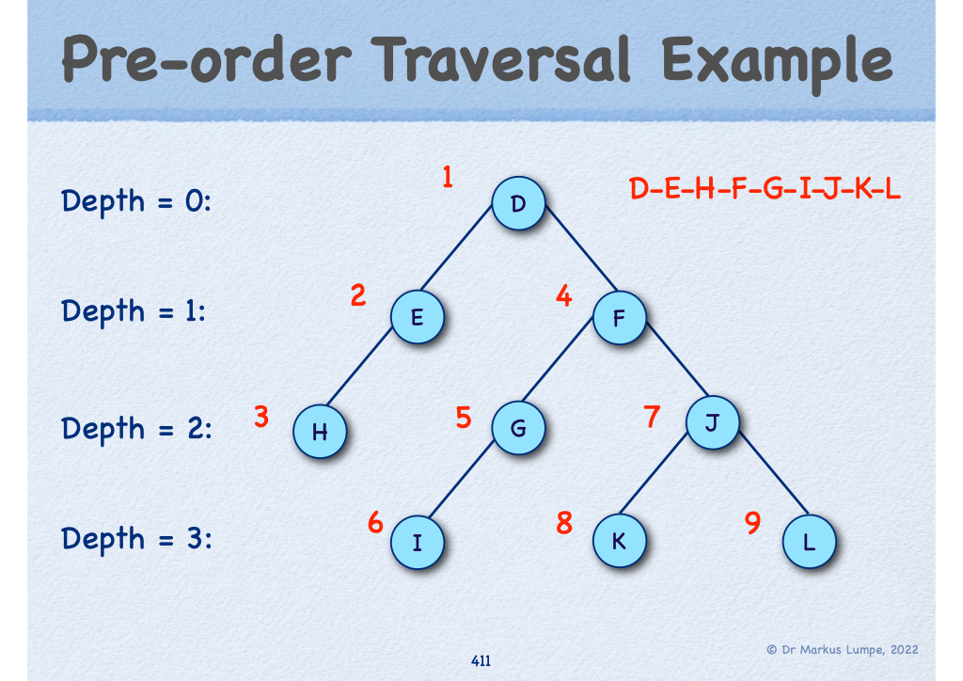

*Figure 1: Pre-order Tree Traversal.*

We wish to extend the basic pre-order traversal to a 3-ary tree. That is, when performing pre- order traversal, we

1. Visit the key,
2. Visit the left subtree,
3. Visit the middle subtree, and
4. Visit the right subtree.

This process is most easily realized via a recursive traversal procedure. However, we seek to implement it using a prefix iterator. That is, we need to use a stack to record the tree nodes that still need to be visited.

Initially, the stack contains only the root of the tree. This allows the iterator to access the key of the root node. When the iterator advances, the top node has to be removed from the stack and all its non-empty subtrees have to be pushed unto the stack from right to left. That is, once the top node has been popped, we need to push first the right subtree, next the middle subtree, and finally the left subtree, if they are not empty. Using this approach, we obtain pre-order traversal for 3-ary trees. To facilitate this task, we can use the method push_subtrees() that pushes all non-empty subtrees of the tree node argument unto the stack from right to left.

A suitable solution for a prefix iterator is given below:

**#pragma once**

**#include** "TernaryTree.h"

**#include** <stack>

**template**<**typename** T>

**class** TernaryTreePrefixIterator

{

**private**:

**using** TTree = TernaryTree<T>;

**using** TTreeNode = TTree**\***;

**using** TTreeStack = std::stack<**const** TTreeNode>;

**const** TTree**\*** fTTree; // ternary tree

TTreeStack fStack; // traversal stack

**public**:

**using** Iterator = TernaryTreePrefixIterator<T>; Iterator **operator++**(**int**)

{

Iterator old = **\*this**;

**++**(**\*this**);

**return** old;

}

**bool operator!=**( **const** Iterator**&** aOtherIter ) **const**

{

**return** !(**\*this ==** aOtherIter);

}

/////////////////////////////////////////////////////////////////////////

// Problem 4: TernaryTree Prefix Iterator

**private**:

// push subtree of aNode [30]

**void** push_subtrees( **const** TTree**\*** aNode );

**public**:

// iterator constructor [12] TernaryTreePrefixIterator( **const** TTree**\*** aTTree );

// iterator dereference [8]

**const** T**& operator\***() **const**;

// prefix increment [12] Iterator**& operator++**();

// iterator equivalence [12]

**bool operator==**( **const** Iterator**&** aOtherIter ) **const**;

// auxiliaries [4,10] Iterator begin() **const**; Iterator end() **const**;

};

Template class TernaryTreePrefixIterator<T> defines a standard forward iterator. To facilitate its implementation there is a private member function push_subtrees(). This function takes a pointer to a constant TernaryTree<T> object and pushes the corresponding subtrees from right to left unto the traversal stack, if there are any.

The prefix increment always removes the top element from the stack. Next, the subtrees of the top element have to be pushed onto the traversal stack from right to left. This yields the required pre-order traversal of a 3-ary tree.

The other iterator methods are defined in the usual way. The constructor has to set up the initial stack. That is, the root node must be pushed onto the traversal stack, if it is not empty.

The equivalence operator tests the addresses of the trees and the respective stack sizes. The iterator is at the end, if the traversal stack is empty.

To complete the solution, you need to implement the iterator methods for class TernaryTree<T>. They are used to map for-range loops to plain for loops in C++. The compiler will report “undefined symbol” if these methods have not been implemented.

You can use #define P4 in Main.cpp to enable the corresponding test driver, if you wish to compile and test your solution. The test driver should produce the following output:

Test Problem 4:

Test prefix iterator: This is a ternary tree in action. It works! Test Problem 4 complete.

No other outputs or errors should occur.

# Problem 5 (50 marks)

Answer the following questions in one or two sentences:

1. How can we construct a tree where all nodes have the same degree? [4]

This is only possible if the degree is 1, forming a two-node tree, or if the degree is 2,

which creates a linear chain.

## 5a)

1. What is the difference between l-value and r-value references? [6]

L-value references bind to persistent objects, whereas r-value references bind to temporary

objects, enabling move semantics and optimizing resource management.

## 5b)

1. What is a key concept of an abstract data types? [4]

It is encapsulation

Encapsulation in abstract data types (ADTs) hides implementation details from the user,

Allowing interaction only via a defined interface.

## 5c)

1. How do we define mutual dependent classes in C++? [4]

Mutual dependency in C++ is managed by forward declaring classes, allowing them to

Reference each other without full definitions at first.

## 5d)

1. What must a value-based data type define in C++? [2]

In C++, a value-based data type requires a copy constructor, an assignment operator, and

a destructor to ensure deep copies and proper resource management.

## 5e)

1. What is an object adapter? [6]

The object adapter design pattern bridges incompatible interfaces by wrapping one

object's interface into another expected by clients, facilitating their collaboration.

## 5f)

1. What is the difference between copy constructor and assignment operator and how do we guarantee safe operation? [8]

The copy constructor in C++ creates a new object as a copy of an existing one, whereas

the assignment operator updates an existing object with another's contents. Both need to

manage self-assignment, free dynamic memory if needed, and perform deep copying for

safe operation.

## 5g)

1. What is the best-case, average-case, and worse-case for a lookup in a binary tree?[6]

The best-case lookup time in a binary search tree is O(1) when the first node is the target.

On average, it's O(log n) in a balanced tree, and in the worst case, O(n) for a degenerate,

linearly arranged tree.

## 5h)

1. What are reference data members and how do we initialize them? [2]

reference data members are class members that reference objects of other classes and

must be initialized when an object is created, usually in the constructor's initialization list,

due to references being non-reassignable post-initialization.

## 5i)

1. You are given n-1 numbers out of n numbers. How do we find the missing number nk, 1 ≤ k ≤ n, in linear time? [8]

To identify the missing number from n-1 out of n numbers, calculate the sum of the first n

natural numbers with S = n(n+1) / 2, then subtract the sum of the n-1 numbers. This

approach, requiring O(n) time

**5j)**